Ramadan Tweet Sheet

Please share the following messages and assets on your social media channels.

To access the images in higher res, select the image and save on to your system.

Focus | Message | Suggested creative
Support  For NHS  Staff | Ramadan Mubarak! We’d like to wish Muslim Londoners and NHS staff all the blessings of the holy month.  Some of #OurNHSPeople will be fasting during #Ramadan and it’s important for colleagues to support one another during this time. Find out more ➡️ https://people.nhs.uk/guides/covid-19-and-ramadan/steps/key-workplace-considerations-during-ramadan/ | 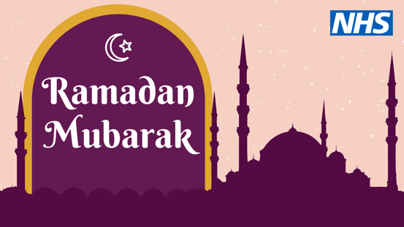
CV19  Vaccine  & fasting | If you’ve been invited to get the #COVIDVaccine, don’t delay during the holy month of #Ramadan.  The @BritishIMA has confirmed that the vaccine is safe and does not invalidate fasting. For more information, watch Dr Salman Waqar share the facts ➡️ youtube.com/watch?v=bqwqSG6icu4&t=87s | 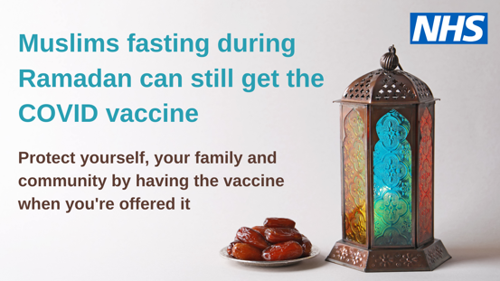
CV19  Vaccine  & fasting | Muslim Londoners fasting this #Ramadan can still have the #COVIDVaccine if they’ve been offered it. If you’re unsure about having the vaccine while fasting, speak to your imam for religious guidance.  For more information from @BritishIMA, visit https://britishima.org/ | 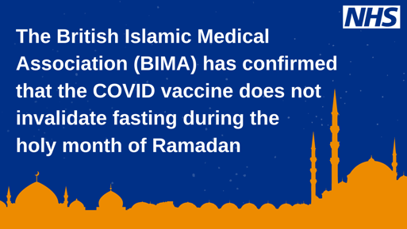
CV19  Vaccine | Dr Abdul Kamali, a GP in Tower Hamlets, shares factual information about having the #COVIDVaccine during #Ramadan.  Don’t delay – protect yourself, your family and community by having the vaccine when you’re offered it. | Download video.
CV19 safety guidelines | Although Iftars during #Ramadan may look different this year, we want to thank Muslim Londoners for following #COVID19 guidance during the holy month to keep themselves, their families and community safe.  For more information on what you can and can’t do, visit gov.uk/coronavirus | 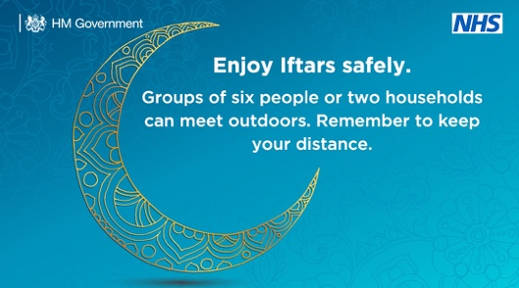
Diabetes management | If you have diabetes and want to fast this #Ramadan, speak to your GP or diabetes nurse about the safest way to do this.  Find out more from @diabetesUK ➡️ https://www.diabetes.org.uk/guide-to-diabetes/managing-your-diabetes/ramadan | 