Mushkil Aasaan

Community Care for Families

(Registered Charity No 1080666)

220-222 Upper Tooting Road

London SW17 7EW

Tel: 020 8672 6581

Email: mushkil@mushkilaasaan.com

اللَّهُمَّ إِنِّي أَعُوذُ بِكَ مِنَ الْبَرَصِ، وَالْجُنُونِ، وَالْجُذَامِ، وَمِنْ سَيِّئِ الأَسْقَامِ
Allah humma inni a'udhu bika minal-barasi, wal-jununi, wal-judhaami, wa min sayyi'il-asqaami

"O Allah, I seek refuge in You from leprosy, insanity, elephantiasis, and the worst of diseases."
[Abu Dawud]

WHEN YOU ENTER MUSHKIL AASAAN FOR ANY ACTIVITY PLEASE:

- ENTER YOUR NAME AND ADDRESS IN THE ATTENDANCE BOOK

- PLEASE ENTER IF YOU HAVE HAD YOUR VACCINE

- USE HAND SANITISER PROVIDED

- DO NOT GET TOO CLOSE TO PEOPLE - KEEP YOUR DISTANCE

- WEAR A FACE MASK

- PLEASE DO NOT ATTEND IF YOU HAVE ANY SYMPTOMS
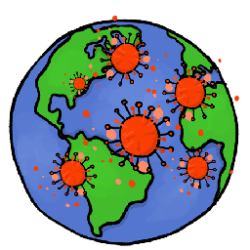
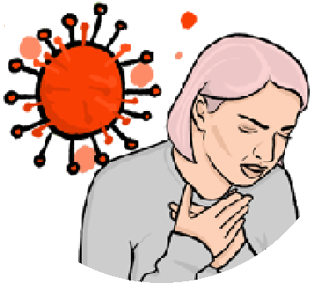

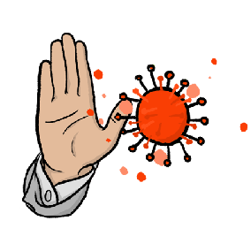
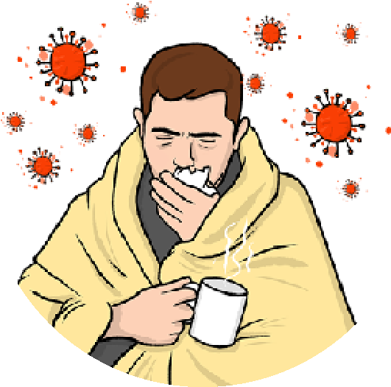
COVID-19 is an illness that is spreading around the world. It can affect your lungs and breathing.
•
•

You should be careful not to catch and spread COVID-19.

Some people who have had the Vaccine can still catch COVID-19 and spread it to other people.

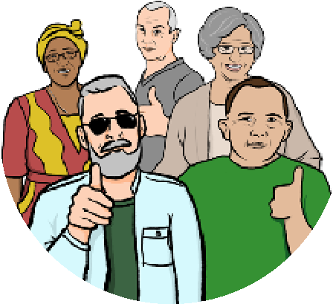
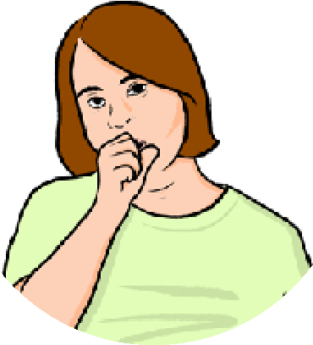
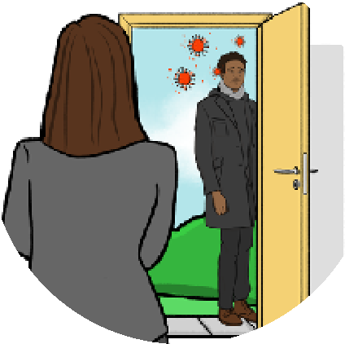
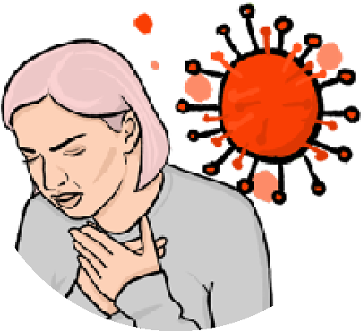
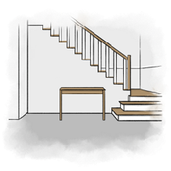
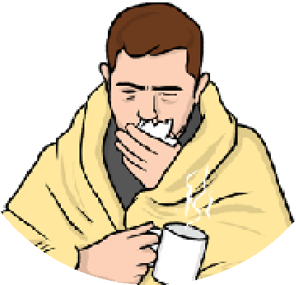
Staying at home if you are unwell

If you have not got COVID-19 but still feel unwell
You may have flu or a cold.
Staying at home until you feel better will stop you spreading an illness.
Many common illnesses are spread by:
- being close to someone
- coughs and sneezes
- touching things that people have breathed on.
If you are feeling ill, you may want to keep away from other people until you feel better.

